Project Title: **Optimizing User, Group, and Role Management with Access Control and Workflows**

**Team Id:** NM2025TMID14999

**Team Members:** 4

**Team Leader:** Aadhitya E

**Team Member 1:** Jeyasurya S

**Team Member 2:**Sridhar K

**Team Member 3:**Ravibharathi P

**Problem Statement:**

In a small project management team consisting of a Project Manager (Alice) and a Team Member (Bob), there is a need to efficiently manage project tasks and ensure accountability throughout the project lifecycle. The current system lacks clear role definitions, access controls, and a structured workflow, leading to confusion regarding task assignments and progress tracking.

**✅ Steps to Create a New User in ServiceNow**

1. **Log in to ServiceNow.**
2. In the left-hand navigation pane, click **“All”** to expand the list of available modules.
3. In the filter navigator (search bar), type **"Users"**.
4. Under the **System Security** section, click on **"Users"**.
5. In the Users list view, click the **“New”** button (usually found at the top of the page).
6. A form will open — fill in the required user details such as:
   * **First Name**
   * **Last Name**
   * **User ID**
   * **Email**
   * **Password** (if applicable)
   * Any other mandatory fields depending on your organization’s setup
7. Once all necessary information is entered, click **“Submit”** to create the user.

**➕ Create Another User in ServiceNow**

1. While still on the **Users** page, click the **“New”** button again to create a second user.
2. Fill in the user details as required. For example:
   * **First Name:** (Enter the user's first name)
   * **Last Name:** (Enter the user's last name)
   * **User ID:** (Choose a unique user ID)
   * **Email:** (Enter the user’s email address)
   * **Password:** (if applicable)
   * Any other required fields
3. After entering the information, click **“Submit”** to save and create the new user.

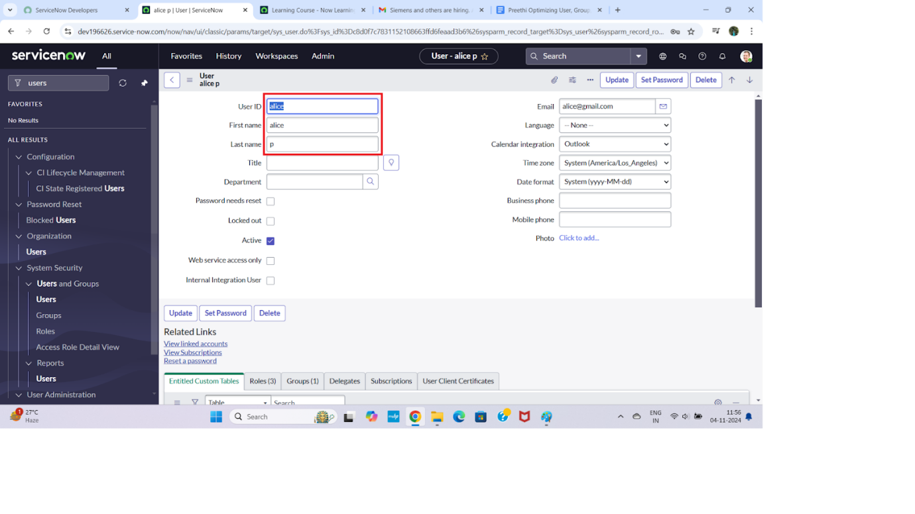

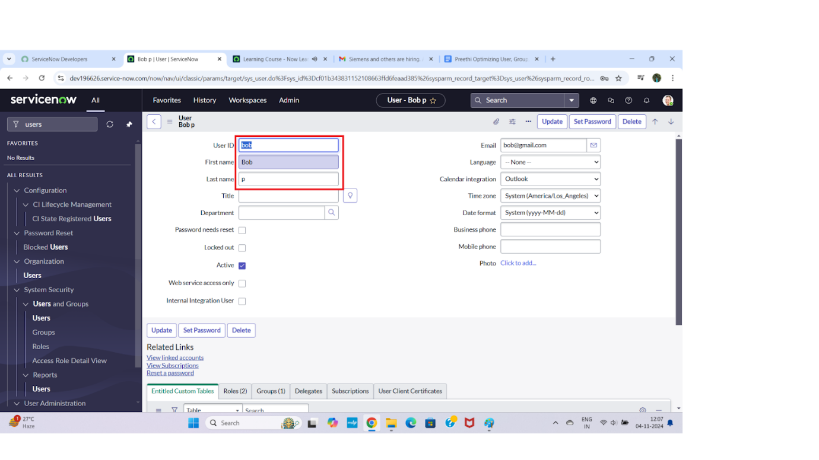

**✅ Steps to Create a New Group in ServiceNow**

**1.Log in to ServiceNow.**

2.In the left-hand navigation panel, click **"All"** to expand the list of modules.

3.In the filter navigator (search bar), type **"Groups"**.

4.Under the **System Security** section, click on **"Groups"**.

5.On the Groups list page, click the **“New”** button to create a new group.

6.Fill in the necessary group details, such as:

* + **Name** (e.g., "IT Support", "HR Team")
  + **Description** (optional but recommended)
  + Add **Users** to the group if required (using the related list at the bottom)

7.Once all required information is entered, click **“Submit”** to create the group

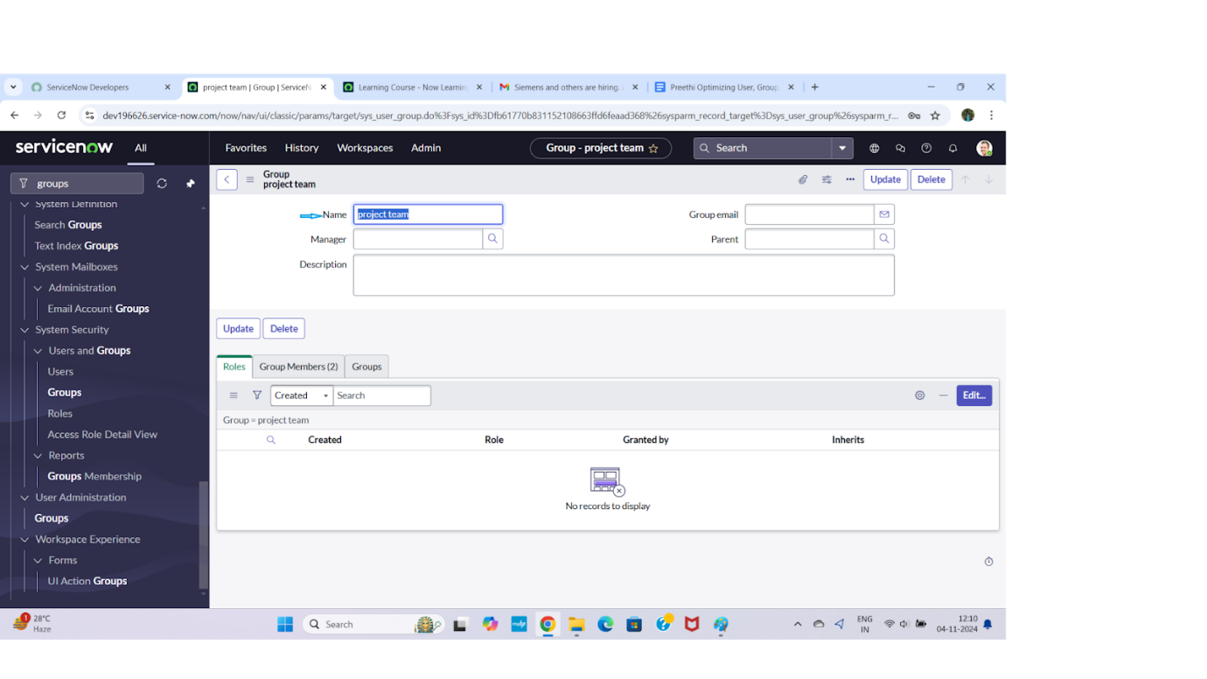

**🔐 Steps to Create a New Role in ServiceNow**

1. **Log in to ServiceNow.**
2. In the left-hand navigation pane, click on **"All"** to display the full list of modules.
3. In the filter navigator (search bar), type **"Roles"**.
4. Under the **System Security** section, click on **"Roles"**.
5. Once the Roles list page loads, click the **“New”** button at the top.
6. In the new role form, fill in the required details:
   * **Name** – A unique name for the role (e.g., it_admin, hr_viewer)
   * **Description** – (Optional) A brief description of what the role is for
   * Add any related permissions or modules, if needed
7. After filling out the form, click **“Submit”** to create the new role.

**➕ Create Another Role in ServiceNow**

8.To create another role, click the **“New”** button again on the **Roles** page.

9.Fill in the following details for the new role:

* + **Name:** team_member
  + **Description:** (Optional) A role for general team members

10.Once the information is entered, click **“Submit”** to save and create the new role.

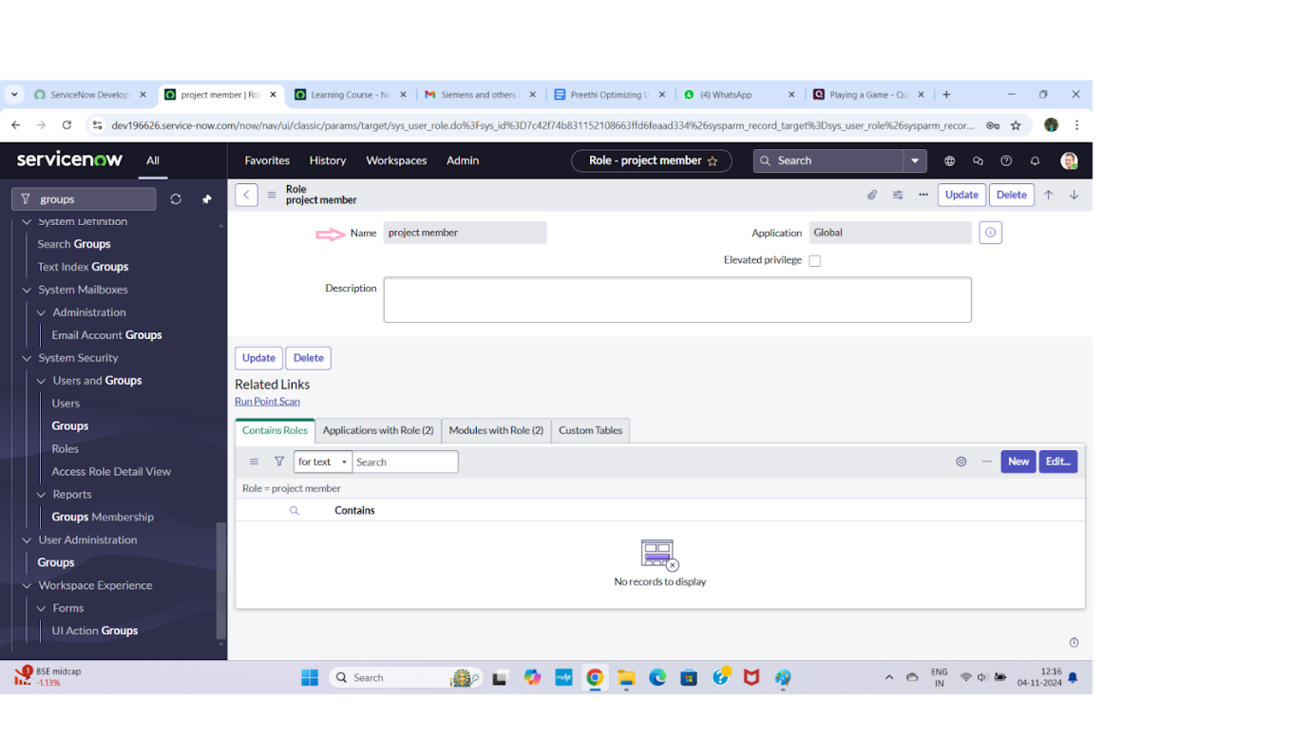

**📋 Steps to Create a New Table in ServiceNow**

1. **Log in to ServiceNow.**
2. In the left-hand navigation pane, click **"All"** to expand the full list of modules.
3. In the filter navigator (search bar), type **"Tables"**.
4. Under the **System Definition** section, click on **"Tables"**.
5. On the Tables list page, click the **“New”** button to create a new table.
6. In the **New Table** form, fill in the following details:
   * **Label:** Project Table
   * Check the boxes:
     + ✅ **Create module**
     + ✅ **Create mobile module**
   * **New menu name:** Project Table
7. Scroll down to the **Columns** section and add the fields/columns you want for the table.  
   For example:
   * **Name** – Type: *String*
   * **Start Date** – Type: *Date*
   * **End Date** – Type: *Date*
   * **Status** – Type: *Choice*
   * **Owner** – Type: *Reference* (referencing User table)
8. After entering all the necessary details and columns, click **“Submit”** to create the new table.
9. After you've added all the required details and table columns, go ahead and click the **“Submit”** button at the bottom of the form to save and create your new **Project Table**.

**➕ Create Another Table in ServiceNow**

1. Back on the **Tables** page, click the **“New”** button again to create a second table.
2. Fill in the details for the new table:

* **Label:** Task Table 2
* ✅ **Check** the boxes for:
  + **Create module**
  + **Create mobile module**
* **New menu name:** Task Table 2

1. In the **Columns** section, add the desired fields. For example:

* **Task Name** – Type: *String*
* **Assigned To** – Type: *Reference* (User table)
* **Priority** – Type: *Choice*
* **Due Date** – Type: *Date/Time*
* **Status** – Type: *Choice*

1. Once all fields are entered, click the **“Submit”** button to save and create the table.

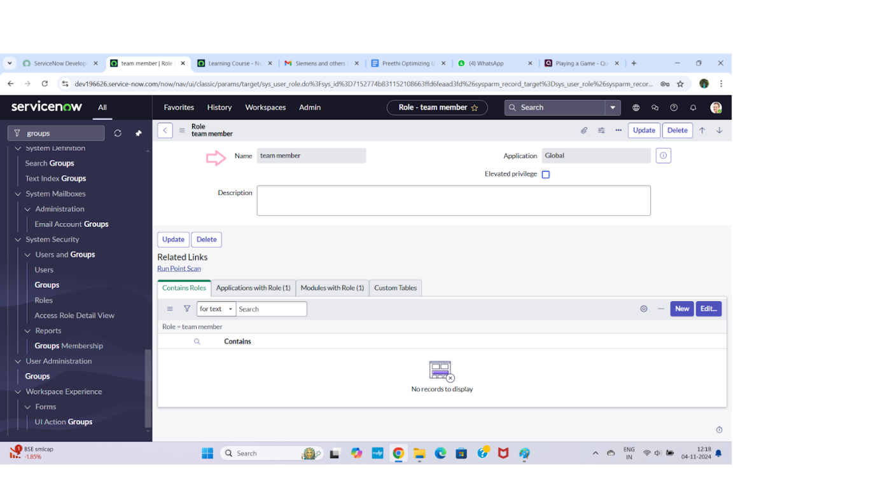

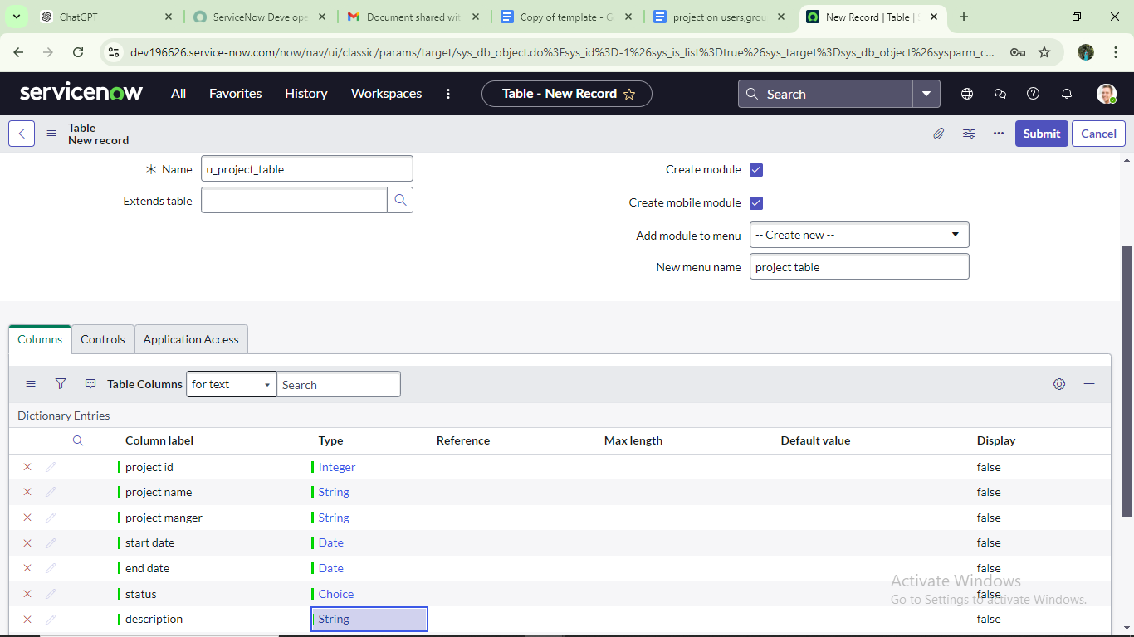

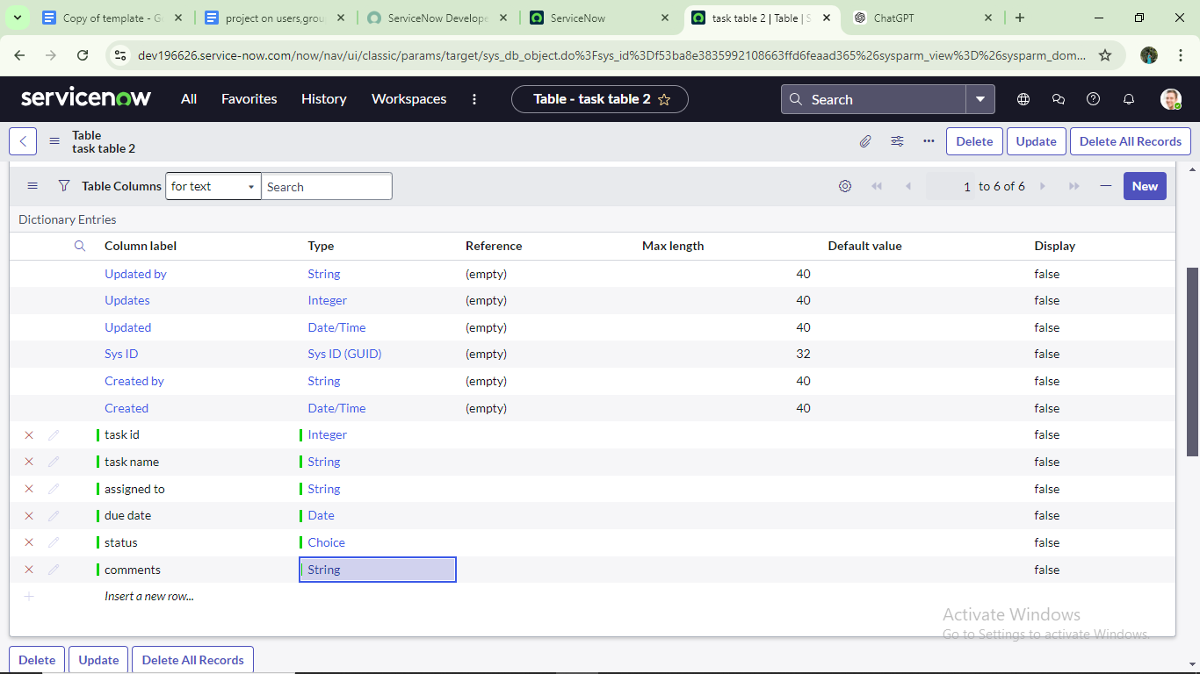

**👥 Add Users to a Group in ServiceNow**

1. **Log in to ServiceNow.**
2. In the left-hand navigation panel, click **“All”** to expand all modules.
3. In the filter navigator, type **“Groups”** and press Enter.
4. Under **System Security**, click on **“Groups.”**
5. From the list of groups, find and click on the **“Project Team”** group.
6. Scroll down to the **Group Members** section (usually a related list at the bottom of the group record).
7. Click the **“Edit”** button in the Group Members section.
8. In the pop-up window:
   * Search for and select **Alice P**
   * Search for and select **Bob P**
   * Use the right arrow (→) to move them to the **Selected** list

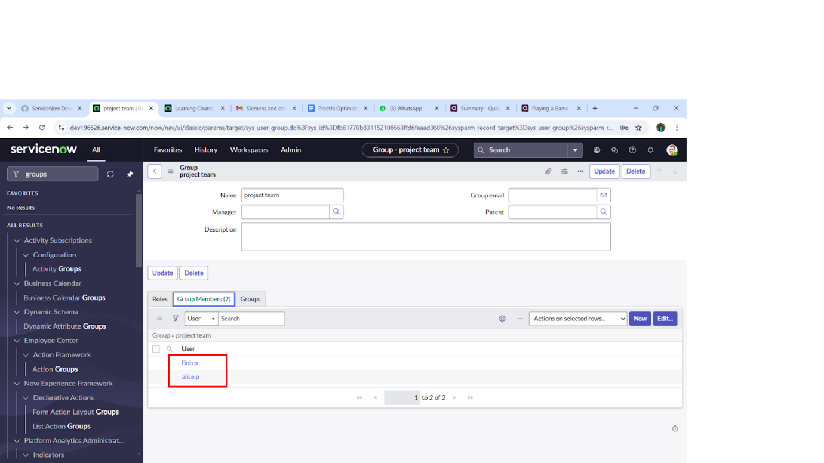

**🎯 Assign Roles to Alice in ServiceNow**

1. **Log in to ServiceNow.**
2. In the left-hand navigation pane, click **“All”** to expand the modules.
3. In the filter navigator, type **“Users”** and press Enter.
4. From the list, find and select the **Project Manager** user (assuming this is Alice’s user record).
5. Scroll to the **Roles** related list on the user’s form.
6. Click **“Edit”** in the Roles section.
7. In the pop-up, select **Project Member** role and move it to the selected list. Click **Save**.
8. Again, click **“Edit”** to add more roles.
9. Search for and add the following roles:
   * u_project_table
   * u_task_table
10. Click **Save** to update the roles.
11. Finally, click **Update** on the user form to save all changes.

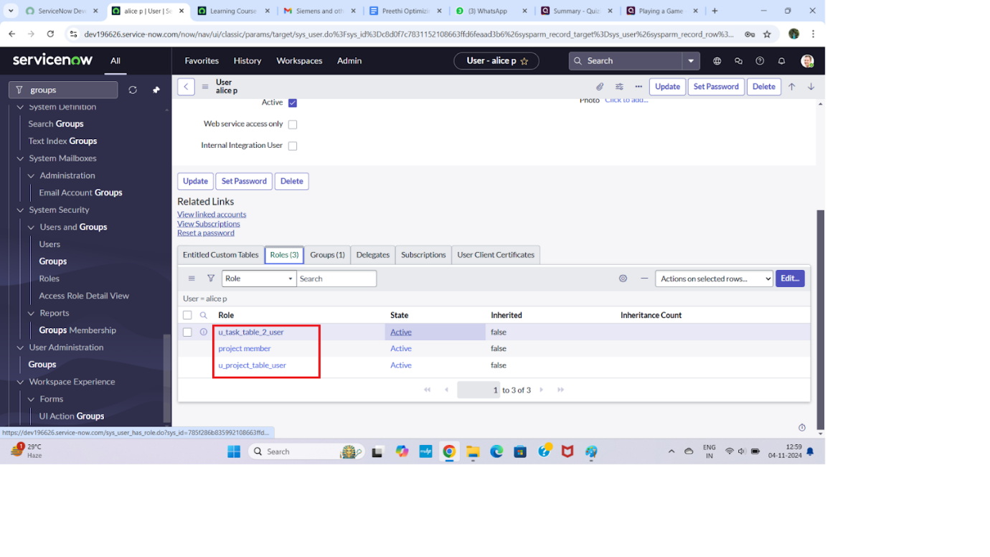

**✅ How to Assign Roles to Bob and Test Access in ServiceNow**

**🔹 Step 1: Open ServiceNow & Search for the User**

1. Log into **ServiceNow**.
2. In the **Application Navigator**, click on **All** or use the search bar.
3. Type and select: **Users** (under the **User Administration** section).

**🔹 Step 2: Find and Open Bob's User Record**

1. In the list of users, search for **Bob P** (or however the username is listed).
2. Click on the record to open **Bob's user profile**.

**🔹 Step 3: Assign the Role**

1. Scroll down to the **Roles** related list.
2. Click **Edit** (next to the Roles section).
3. In the **Collection box**, search and select the role(s):
   * team_member
   * Any **table-specific role** needed (e.g., one tied to Task Table2).
4. Click **Add →** and then **Save** or **Update**.

**🔹 Step 4: Impersonate Bob to Test Access**

1. Click on your **profile icon** (top-right corner of the screen).
2. Choose **Impersonate User** → Search and select **Bob P**.
3. You are now viewing ServiceNow as Bob.

**🔹 Step 5: Verify Access**

1. In the Application Navigator (while impersonating Bob), search for:
   * **Task Table2**
2. If Bob has the correct roles, **Task Table2** should now be visible and accessible.

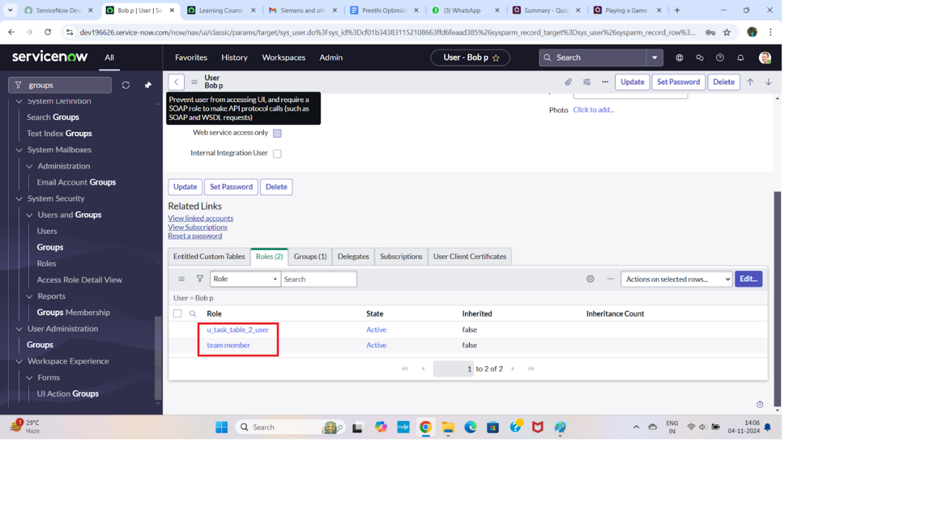

**✅ Assign Table Access to an Application (Humanized Instructions)**

When you create a new table in ServiceNow (or a similar system), an **Application** and a **Module** are automatically created for that table. Follow these steps to update access roles:

**1. Create the Table**

* When you create a new table (e.g., Project or Task Table 2), the system will automatically:
  + Create an **Application** associated with that table.
  + Add a **Module** under that application in the navigator.

**2. Find the Application in the Navigator**

* Go to the **Application Navigator**.
* Search for your table’s application:
  + Type: Project → select the **Project Table Application**.
  + Type: Task Table 2 → select the **Task Table 2 Application**.

**3. Edit the Application Module**

* Click on the **Edit Module** or **Edit Application** (depending on what shows up).
* You’ll now be in the application/module settings.

**4. Assign Roles**

* For the **Project Table Application**:
  + Add the role: project_member
* For the **Task Table 2 Application**:
  + Add both roles: project_member and team_member

**🔒 Why Assign Roles?**

Assigning roles ensures only users with the right permissions can access the application and view/edit data related to those tables.

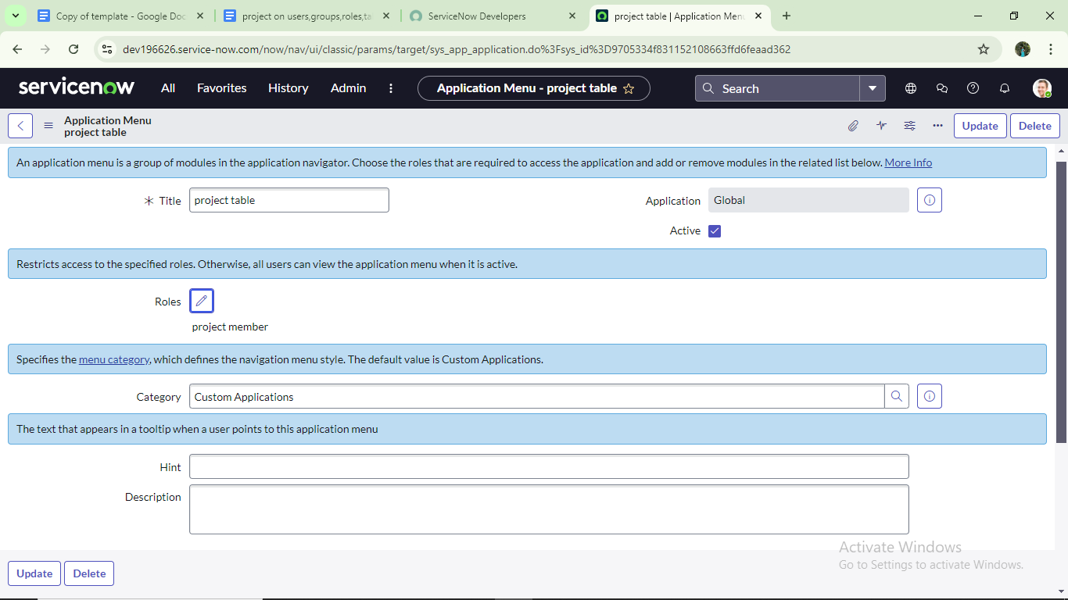



**✅ Step 1: Open ServiceNow & Navigate to ACL**

1. **Login** to your **ServiceNow** instance.
2. In the **Application Navigator** (left sidebar), click on **All**, or simply use the search bar.
3. Search for:
4. ACL
5. Under **System Security**, click on:  
   **Access Control (ACL)**

**🔒 Step 2: Elevate Your Role (if required)**

1. Click on the **profile icon** (top right corner).
2. Choose **Elevate Roles**.
3. Check the box for:
   * security_admin
4. Click **OK** to confirm elevation.

⚠️ Elevating to security_admin is required to create or modify ACLs.

**➕ Step 3: Create a New ACL**

1. On the **Access Control (ACL)** list page, click the **New** button.

**📝 Step 4: Fill in ACL Details**

1. Fill in the necessary fields. Here's an example:

| **Field** | **Value** |
| --- | --- |
| **Type** | Record |
| **Operation** | Read / Write / Create / Delete (choose as needed) |
| **Name** | Select the Table (e.g., task_table2) |
| **Requires Role** | Select the role(s) required (e.g., team_member, project_member) |
| **Condition** | Add optional conditions for access (e.g., Active is true) |
| **Script** | (Optional) Add custom script logic to evaluate access |

1. Once everything is filled out, click **Submit**.

**✅ After Creating a New ACL (continued):**

1. Scroll down to the **Requires Role** related list.
2. **Double-click** on the empty row that says:  
   "Insert a new row..."
3. In the popup or inline form:
   * **Table**: Select the relevant table (e.g., task_table2)
   * **Role**: Select team_member
4. Click **Submit** (or checkmark ✓ if inline).

**🔁 Step: Create 4 ACLs for Specific Fields**

Repeat the ACL creation steps for each of the following **fields** (assuming these are on the same table, e.g., task_table2):

| **Field Name** | **Operation** | **Role(s) Required** |
| --- | --- | --- |
| short_description | Read | team_member |
| state | Write | team_member |
| assigned_to | Read | project_member |
| description | Write | project_member |

**🔄 How to Do It:**

For **each field**, follow these steps:

1. Go to **Access Control (ACL)** → Click **New**.
2. Set **Type**: record
3. Set **Operation**: (Read / Write as needed)
4. Set **Name**: Select the **Table** (e.g., task_table2) → then choose the **Field** (e.g., short_description)
5. Scroll down to **Requires Role** → Insert the required role (team_member or project_member)
6. Click **Submit**

**✅ Step 1: Impersonate the User (Bob)**

1. Click on your **profile icon** in the **top-right corner** of the screen.
2. Choose **Impersonate User** from the dropdown menu.
3. In the user search box, type and select:  
   **Bob** (or Bob P, depending on the full name).
4. You are now logged in as **Bob**.

**✅ Step 2: Navigate to the Application**

1. In the **Application Navigator** (left menu), click **All** or use the search bar.
2. Search for:  
   **Task Table2** (the custom app/module you created).
3. Click to open the **Task Table2** list or form.

**✅ Step 3: Verify Field-Level ACLs**

1. Open any record from the **Task Table2** list.
2. Check the following fields:
   * **Comment**: ✅ Should be **editable**.
   * **Status**: ✅ Should be **editable**.

💡 If Bob can successfully edit these fields, it confirms that the ACLs and roles (team_member, project_member) are correctly applied.

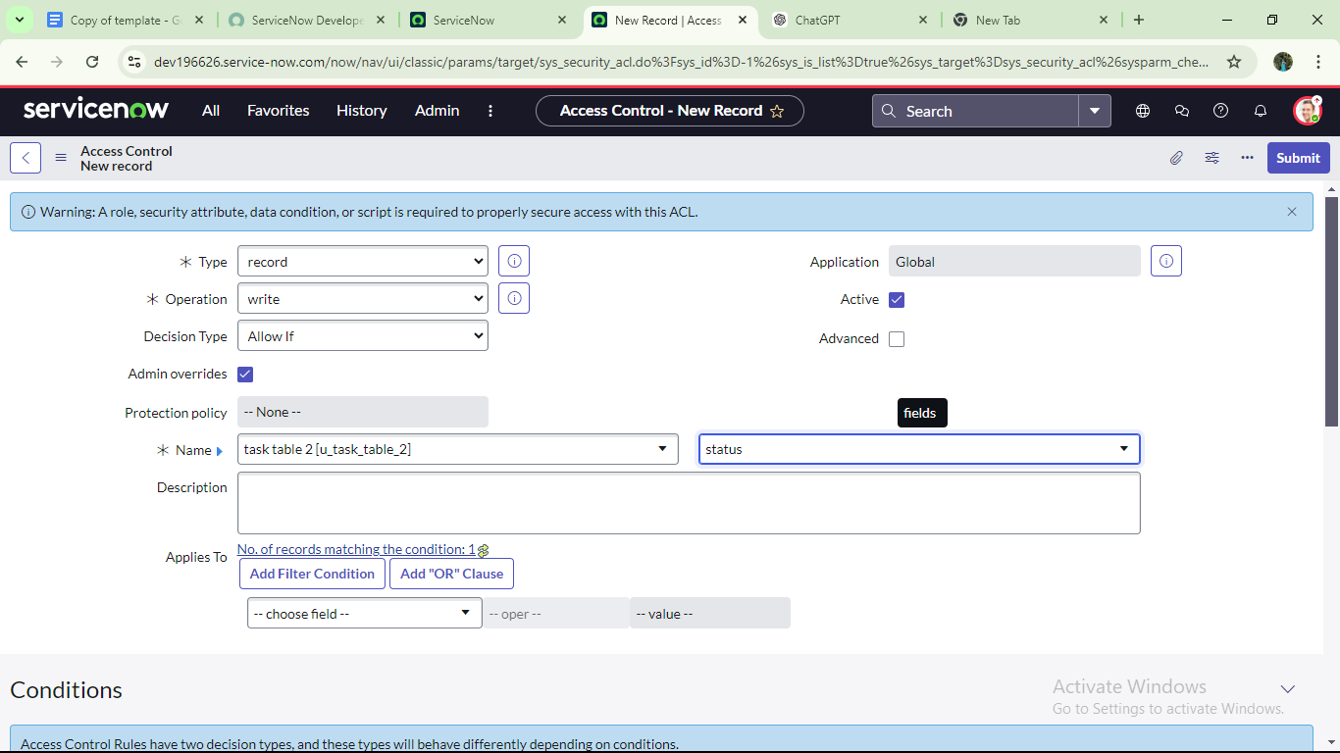

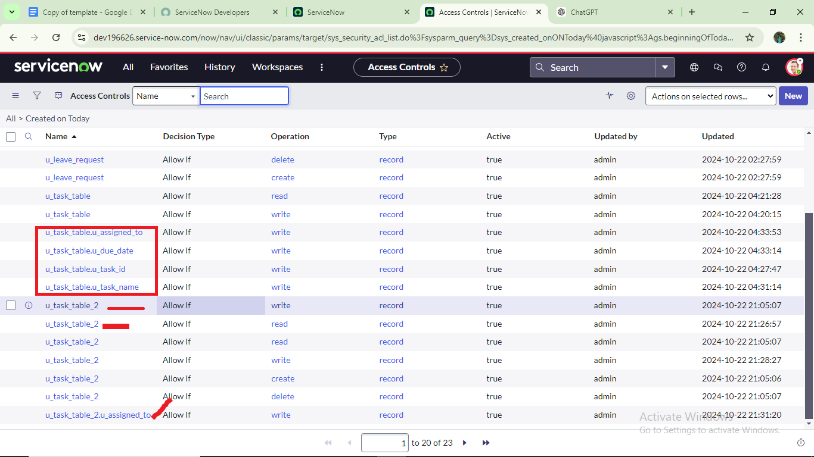

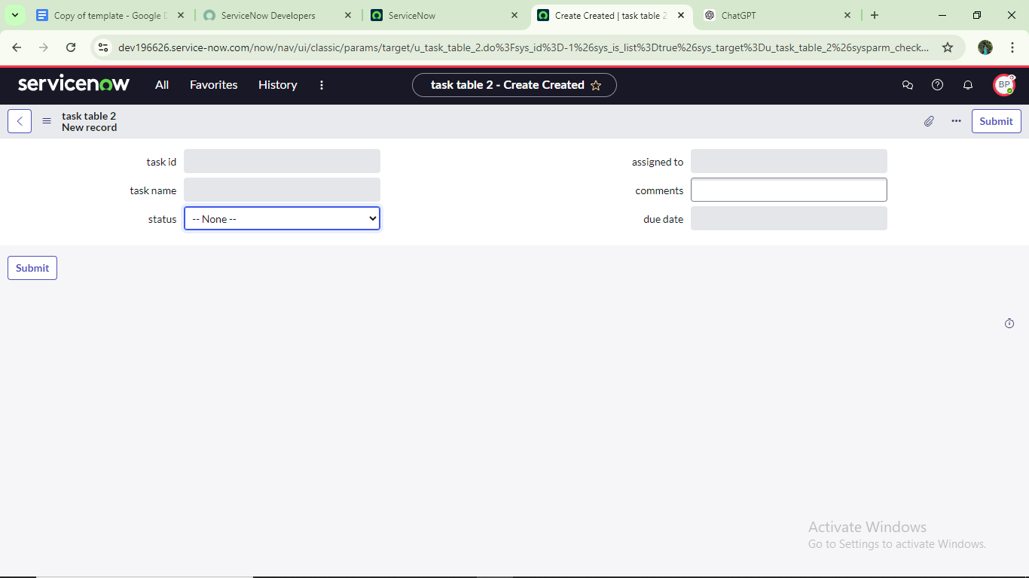

**🔁 Create a Flow to Assign Operations Ticket to a Group in ServiceNow**

**✅ Step 1: Open Flow Designer**

1. Log into **ServiceNow**.
2. In the **Application Navigator**:
   * Click on **All** or use the search bar.
   * Type: Flow Designer
3. Click on **Flow Designer** under the **Process Automation** section.

**✅ Step 2: Create a New Flow**

1. Once Flow Designer opens, click the **New** button (top right).
2. A popup will appear for flow details:
   * **Name**:
   * task table
   * **Application**:
   * Global
3. Click **Submit** (or **Next**, depending on your version).
4. Then click **"Click to continue"** or **"Create Flow"** to start building the flow.

**✅ Step 3: Define the Trigger**

1. Under **Trigger**, click **+ Add Trigger**.
2. Choose:
   * **Table**: Task Table (or your custom table like task_table2)
   * **Trigger Conditions**:
     + **Created** or **Updated** (depending on your use case)
3. Click **Done**.

**✅ Step 4: Add Action – Assign to Group**

1. Click **+ Add Action**
2. Choose:

* **ServiceNow Core** → **Update Record**

1. Set the following:

* **Table**: Task Table
* **Record**: Use data pill (e.g., Trigger → Record)
* **Fields to Update**:
  + **Assignment Group** → Select the group (e.g., Operations or your custom group)

1. Click **Done**.

**✅ Step 5: Save & Activate**

1. Click **Save**.
2. Then click **Activate** to turn on the flow.

**▶️ Step: Add a Trigger for Record Creation with Specific Conditions**

**✅ Step 1: Add a Trigger**

1. In the **Flow Designer**, click on **“+ Add Trigger”** (if you haven't already).

**✅ Step 2: Select Trigger Type**

1. In the trigger selection window:
   * Search for:
   * Create Record
   * Select the trigger type: **Created Record**

**✅ Step 3: Configure the Trigger**

1. Set the following values:
   * **Table**:
   * task table

**✅ Step 4: Add Trigger Conditions**

1. Under **Conditions**, click **+ Add Condition** three times and fill them out as follows:

| **Field** | **Operator** | **Value** |
| --- | --- | --- |
| Status | is | In Progress |
| Comments | is | feedback |
| Assigned to | is | Bob |

💡 Use the field picker to ensure correct field names, and select "Bob" from the user list for Assigned to.

**✅ Step 5: Finish Trigger Setup**

1. Click **Done** to save the trigger configuration.

✅ **Trigger Set!**  
Now, this flow will **run automatically** when a new record is created in the task table **with the following conditions**:

* Status = *In Progress*
* Comments = *feedback*
* Assigned to = *Bob*

**🔧 Step: Add an Action to Update the Record in Flow Designer**

**✅ Step 1: Add an Action**

1. After setting up the trigger, click on **“+ Add Action”** below it.

**✅ Step 2: Select Action Type**

1. In the action selection window:
   * Search for:
   * Update Record
   * Click on **Update Record** (under **ServiceNow Core**).

**✅ Step 3: Configure the Action**

1. In the **Record** field:
   * From the **Data Panel** on the right side, expand the **Trigger** section.
   * Drag the **Record** data pill into the **Record** field of the action.
2. The **Table** will be auto-filled based on the record (e.g., task table).

**✅ Step 4: Set Fields to Update**

1. Under **Fields to update**, click **+ Add Field**.
2. Set the following:
   * **Field**: Status
   * **Value**: Completed (select from dropdown if available)

**✅ Step 5: Save the Action**

1. Click **Done** to complete this action setup.

**✅ Final Verification: Check If Status Was Updated**

**🔍 Step 9: Search for the Task Table**

1. In the **Application Navigator** (left-hand side):
   * Click **All** or use the search bar.
   * Type:
   * task table
   * Select the relevant **Task Table** module from the results (this should open the list of records).

**📋 Step 10: Verify Record Update**

1. Look through the list of records or use filters to find the one that matches:
   * **Status**: *In Progress*
   * **Comments**: *feedback*
   * **Assigned to**: *Bob*
2. Open the record.
3. ✅ Confirm that the **Status field** has been **automatically updated to "Completed"** — this means your **flow ran successfully**!

🎉 **Flow Verified!**  
You’ve now built and tested a working **Flow in ServiceNow** that:

* Triggers on record creation with specific conditions.
* Automatically updates the record’s status field.

**✅ Step 11–13: Approve a Request from My Approvals (as Alice)**

**🔍 Step 11: Open "My Approvals"**

1. In the **Application Navigator** (left panel):
   * Click **All** or use the search bar.
   * Type:
   * My Approvals
2. Under the **Service Desk** section, click on:  
   **My Approvals**

**👤 Step 12: View Alice P’s Approval Requests**

1. Ensure you’re logged in **as Alice P** or impersonating her.

If not already impersonating, click your profile icon > **Impersonate User** > select **Alice P**.

1. You’ll now see a list of approval records assigned to Alice.

**🟢 Step 13: Approve the Request**

1. Locate the relevant approval request in the list.
2. Right-click on the **Requested** status field of that record.
3. From the context menu, click on:  
   **Approve**

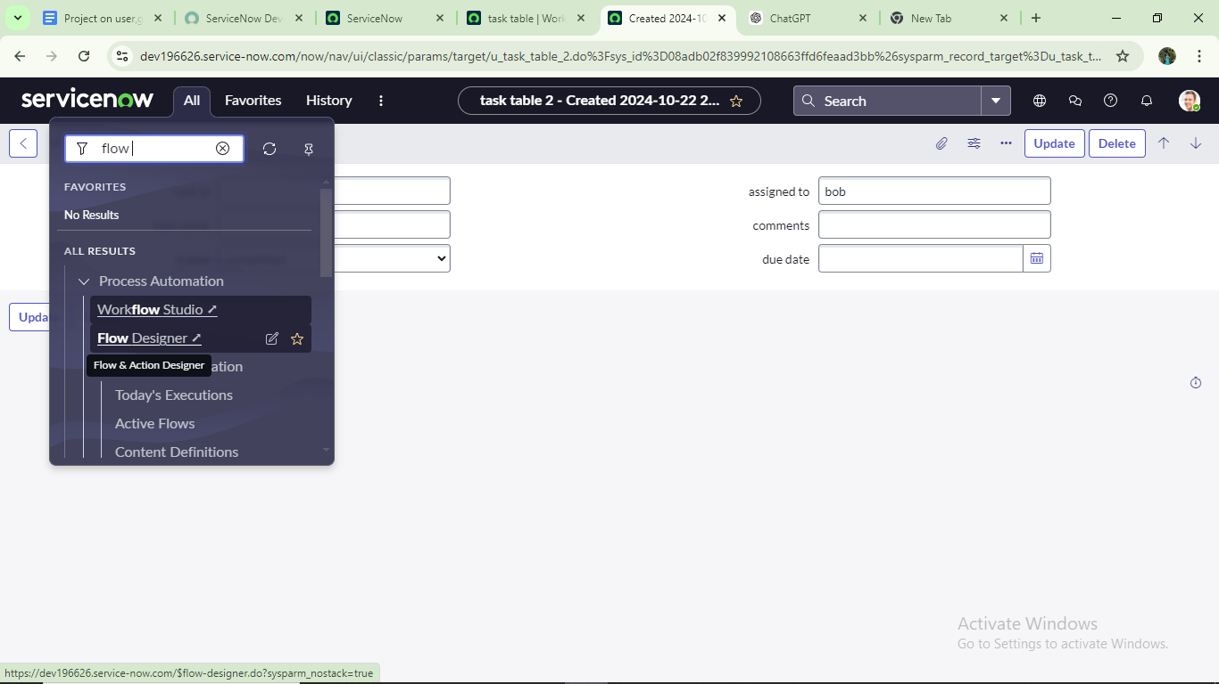

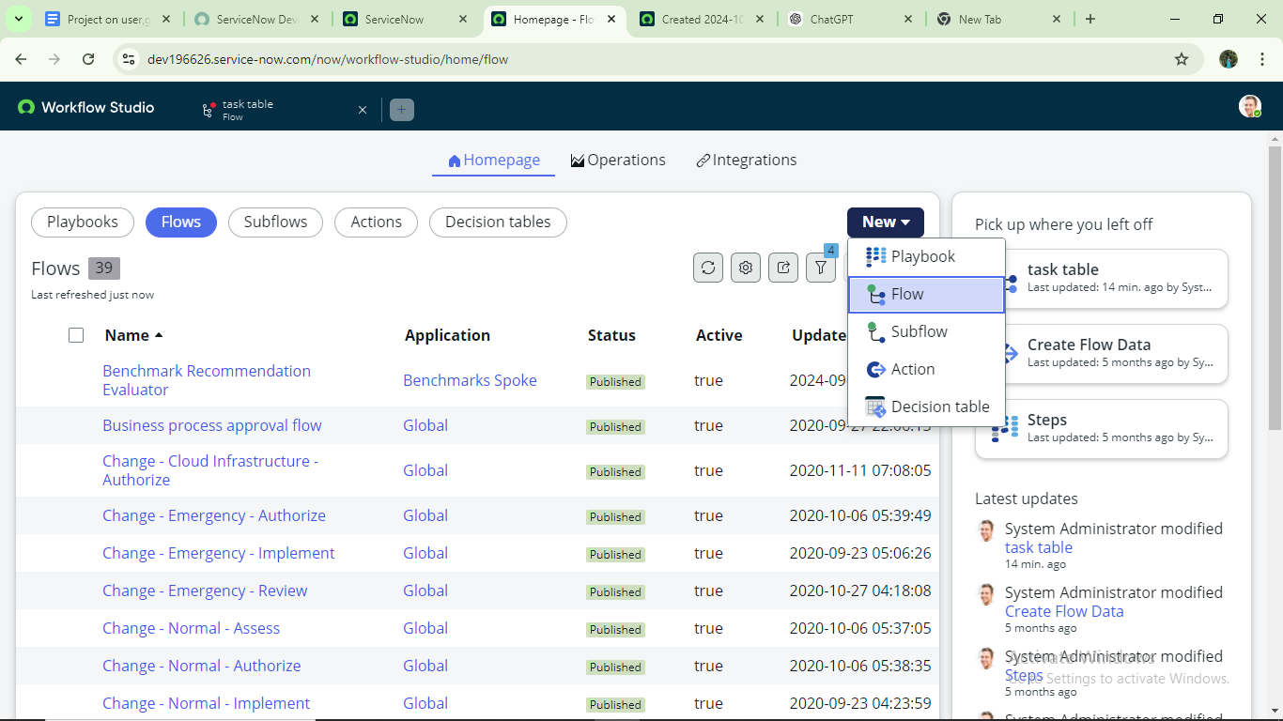

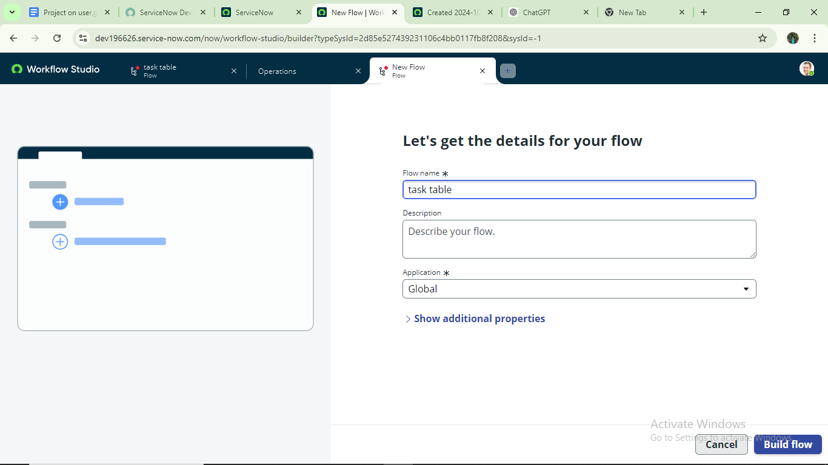



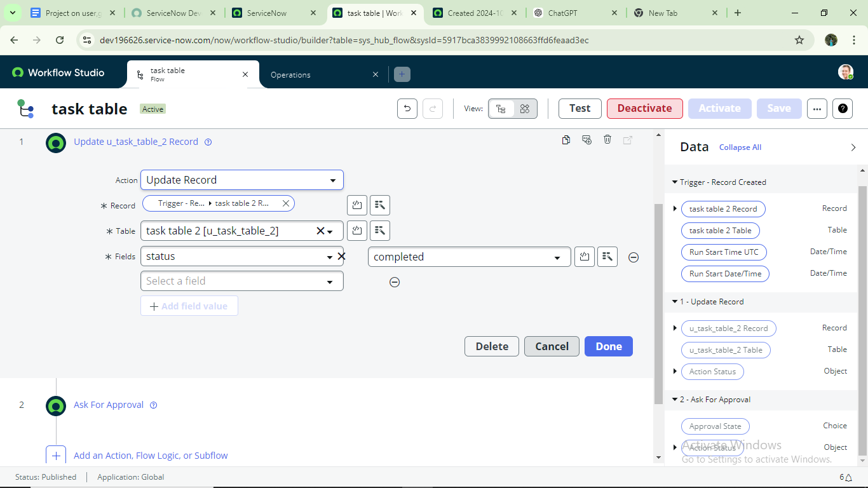

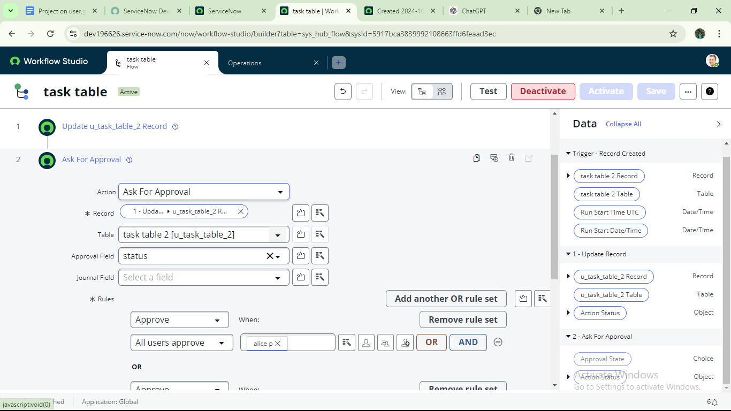





**Conclusion**  
This scenario demonstrates how a well-structured approach to project management can make a real difference. With Alice guiding the overall direction and Bob handling the hands-on execution, the team works together smoothly to move projects forward. Organizing key details in tables helps everyone stay on the same page, making it easier to track tasks, monitor progress, and manage responsibilities. In the end, this setup boosts accountability, improves communication, and helps ensure projects are completed successfully.